**Ten Steps of Market Segmentation Analysis**

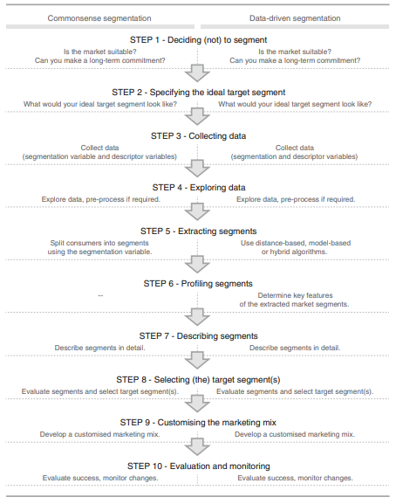

**Step 1: Deliberating the Journey**

Market segmentation, a powerful marketing strategy, has reshaped the landscape for numerous organizations. However, before embarking on this transformative journey, it's vital to grasp the implications entwined with committing to a market segmentation strategy.

***Highlighted Points:***

* Market segmentation demands a long-term commitment.
* Substantial investments are necessary for research, surveys, tailored packaging, and communication across various segments.
* Adaptations might involve introducing new products, revamping existing ones, adjusting pricing and distribution channels, and reshaping communication strategies.
* A cultural shift may be required, organizing around market segments rather than products.
* Senior executives must drive the decision-making process and ensure ongoing support throughout the organization.

*Navigating Implementation Barriers:*

While market segmentation promises great rewards, it's not without its share of challenges. Unveiling the path to success requires navigating through potential implementation barriers.

***Highlighted Points:***

* Leadership and commitment from senior management are critical to its success.
* Organizational culture must embrace change, creativity, and collaboration across departments.
* Comprehensive training is indispensable for understanding market segmentation concepts and implications.
* A qualified marketing expert, data manager, and analyst are vital assets for effective execution.
* Financial resources, market diversity, and adaptability play pivotal roles in overcoming objective restrictions.
* Proactive planning, structured processes, and clear responsibilities are indispensable for a successful journey.

*Unfolding the Checklist:*

Embarking on this transformative journey requires a well-charted roadmap. Here's a checklist to ensure your organization is prepared to unlock the potential of market segmentation.

***Highlighted Points:***

* Assess if the organizational culture is market-oriented and open to embracing change.
* Gauge the organization's willingness to commit to long-term strategies and accept new ideas.
* Secure visible and active commitment from senior management for market segmentation.
* Ensure a well-rounded team with marketing and data experts is in place for a smooth execution.
* Form an advisory committee to represent all affected organizational units and foster collaboration.
* Clarify objectives, develop a structured process, and allocate responsibilities for the segmentation team.
* Allocate sufficient time for the analysis, free from undue pressure.
* Most importantly, embrace a resolute sense of purpose, dedication, patience, and a readiness to tackle inevitable challenges.

**Step 2: Specifying the Ideal Target Segment**

In Step 2 of the market segmentation analysis, the organization focuses on determining the ideal target segment based on user input and segment evaluation criteria. The third layer of market segmentation analysis relies heavily on user involvement throughout the process, not just in the beginning or end stages.

***Segment Evaluation Criteria***

* The organization must actively participate in most stages of the market segmentation analysis, guiding critical steps like data collection and selecting target segments.
* The two sets of segment evaluation criteria are knock-out criteria and attractiveness criteria.
* Knock-out criteria are essential and non-negotiable features that eliminate segments not suitable for targeting.
* Attractiveness criteria are used to assess the relative attractiveness of remaining market segments, guiding the selection of target segments.
* A wide range of proposed criteria is available in the literature, and the segmentation team must select the most suitable ones for their specific situation.

***Knock-Out Criteria***

* Knock-out criteria determine if market segments qualify for further evaluation based on homogeneity, distinctness, size, match, identifiability, and reachability.
* They are non-negotiable and automatically eliminate segments that do not comply.

***Attractiveness Criteria***

* + Attractiveness criteria are used to rate segments based on their attractiveness relative to each specific criterion.
  + They are not binary; each segment is rated as more or less attractive for a specific criterion.

***Implementing a Structured Process***

* + Following a structured process for segment evaluation is recommended.
  + A segment evaluation plot, showing segment attractiveness and organizational competitiveness, is a popular approach.
  + The criteria and their weights are negotiated and agreed upon by the segmentation team and may involve input from the advisory committee, representing various organizational units.

***Step 2 Checklist***

* + Convene a segmentation team meeting and agree on knock-out criteria.
  + Present the knock-out criteria to the advisory committee for discussion.
  + Individually study and agree on a subset of no more than six segment attractiveness criteria.
  + Distribute points across the selected attractiveness criteria to reflect their relative importance.
  + Discuss and agree on the weighting of the criteria with the segmentation team.
  + Present the selected criteria and weights to the advisory committee for discussion and adjustment.

In Step 2, the organization lays the groundwork for data collection in Step 3 and the selection of a target segment in Step 8 by specifying the segment evaluation criteria and their weights based on user input and organizational priorities.

**Step 3: Collecting Data**

In Step 3, the market segmentation team collects empirical data to form the basis for segment extraction. The selection of suitable segmentation variables and careful design of the data collection process are crucial to obtaining high-quality data for market segmentation analysis.

***Selection of Segmentation Variables***

* + In commonsense segmentation, one characteristic of consumers serves as the segmentation variable, while other characteristics serve as descriptor variables.
  + Data-driven segmentation uses multiple segmentation variables to identify or create market segments based on specific criteria, such as benefits sought or specific behaviors.

***Data from Survey Studies***

* + Survey data is the most common source of data for market segmentation studies.
  + The quality of survey data is critical to obtaining reliable segmentation results.
  + Response options, sample size, and the inclusion of relevant and non-redundant variables are important considerations in survey design.

***Data from Internal Sources***

* + Organizations can utilize internal data, such as scanner data or booking data, for market segmentation analysis.
  + Internal data provide insights into actual consumer behavior and do not rely on self-reported responses.

***Data from Experimental Studies***

* + Experimental data, resulting from field or laboratory experiments, can be used for market segmentation analysis.
  + Conjoint analyses and choice experiments provide information about consumer preferences for specific product attributes.

In Step 3, the team carefully designs the data collection process to ensure the validity and quality of the collected data. The collected data forms the basis for the subsequent steps in market segmentation analysis, including segment extraction and description.

**Step 8: Selecting the Target Segment(s)**

In Step 8 of the market segmentation analysis, the focus shifts to making a crucial decision – which market segment(s) to target with the organization's marketing efforts. This step is the culmination of the segmentation process, where all the groundwork laid in previous steps comes together to identify the most promising target segment(s) for the organization.

***1. Reviewing Knock-Out Criteria:*** The first task is to ensure that all the market segments still under consideration have successfully met the knock-out criteria. These criteria, including factors like segment size, homogeneity, distinctness, match, identifiability, and reachability, help filter out segments that may not be suitable for targeting.

***2. Evaluating Segment Attractiveness:*** The segmentation team needs to evaluate the attractiveness of the remaining segments from the organization's perspective. This involves asking questions such as: Which segment(s) align most with the organization's goals and values? Which segment(s) are most likely to yield the highest returns on marketing efforts?

***3. Assessing Organizational Competitiveness:*** The team should also consider the organization's competitiveness for each segment. How well can the organization meet the needs and preferences of each target segment? Is the organization well-positioned to serve these segments effectively?

***4. Segment Evaluation Plot:*** One useful way to visualize and compare the attractiveness and competitiveness of each segment is by using a segment evaluation plot. The plot may have the segment attractiveness on the x-axis and organizational competitiveness on the y-axis, with each segment appearing as a circle on the plot. The size of the circle may represent another relevant criterion, such as potential profitability.

***5. Target Segment Decision:*** Based on the segment evaluation plot and the data collected, the segmentation team can make a preliminary selection of the target segment(s) that align best with the organization's goals and capabilities. Care should be taken to ensure that the selected target segment(s) are compatible with each other, especially if the organization intends to target more than one segment.

***6. Advisory Committee Review:*** The selected target segment(s) should be presented to the advisory committee for further discussion and potential reconsideration. Input from key stakeholders helps validate the decision and ensures that all perspectives are taken into account.

By following these steps, an organization can make an informed decision on which market segment(s) to target with their marketing efforts, maximizing the effectiveness of their marketing strategies and increasing the likelihood of business success.